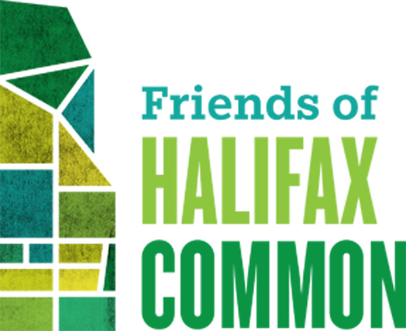

"To and for the use of the inhabitants of the town of Halifax as Common forever" (1763-2013)

Bibliography - importance of greenspace for mental and physical well-being.

http://stud.epsilon.slu. se/8102/1/insulander_a_150624.pdf

http://bloomingrock.com/2015/02/02/5-ways-to-add-density-without-building-high-rises/

https://www.washingtonpost.com/news/wonk/wp/2015/05/04/in-the-shadows-of-booming-cities-a-tension-between-sunlight-and-prosperity/?utm_term=.e6d92e748631

http://www.smartcitiesdive.com/ex/sustainablecitiescollective/7-reasons-why-high-rises-kill-livability/561536/

https://salvolomas.wordpress.com/2011/02/28/more-low-down-on-tall-buildings-new-urban-net/

http://www.newgeography.com/content/003938-city-leaders-are-love-with-density-most-city-dwellers-disagree

http://www.cbc.ca/news/health/green-spaces-lower-mortality-1.3150812

https://www.researchgate.net/publication/280304507_Challenges_and_strategies_for_urban_green-space_planning_in_cities_undergoing_densification_A_review

https://mailchi.mp/climatenewsnetwork/trees-shade-can-cool-cities-by-5c?e=5c82a0337f Trees' shade can cool cities by 5°C

https://www.curbed.com/2019/10/3/20897300/parks-climate-change-pollution-landscape-architects?silverid=%25%25RECIPIENT_ID%25%25&mc_cid=56c9796d13&mc_eid=115e36e4d1
https://www.cbc.ca/news/technology/air-pollution-study-1.5339472

